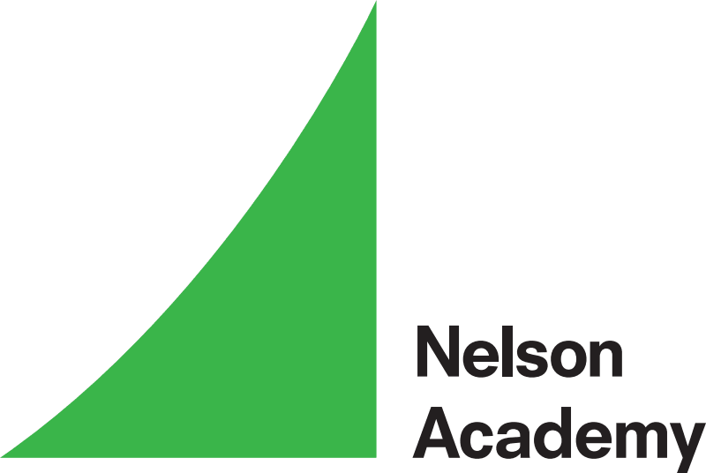
‘Achieving Through Learning’
Religious Education Policy 2025-26
Purpose
Religious Education is a compulsory subject and forms part of the National Curriculum to which every pupil should have access. It can provide the foundation for many people’s lives, and promote acceptance and understanding of other beliefs, which links well to British Values. Through the teaching of RE we aim to promote the spiritual, moral, social and cultural development of all pupils. The RE syllabus that we are currently following at Nelson Academy is ‘Discovery RE scheme’ which allows us to provide a great coverage of the main religious by using a key question to influence our learning, as well as making sure that what we are teaching is in line with the ‘Norfolk Agreed Syllabus 2019: A Religious Education for the Future’. At Nelson Academy we enable children to develop a sound knowledge of the 5 major religions, with emphasis placed on Christianity which will be studied in greater depth. Both religious and non-religious world views are studied. Children reflect on what they have learnt and are encouraged to share their views within a safe space. They are encouraged to develop their own spiritual knowledge and understanding which should help children to learn from children and how it will support them to think differently in their everyday lives.

Aims
In accordance to the ‘Agreed Norfolk Syllabus 2019 our aims for the teaching of Religious Education is the following:
- To know about and understand a range of religious and non-religious worldviews by learning to see these through theological, philosophical and human/social science lenses.
- To express ideas and insights about the nature, significance and impact of religious and non-religious worldviews through a multi-disciplinary approach.
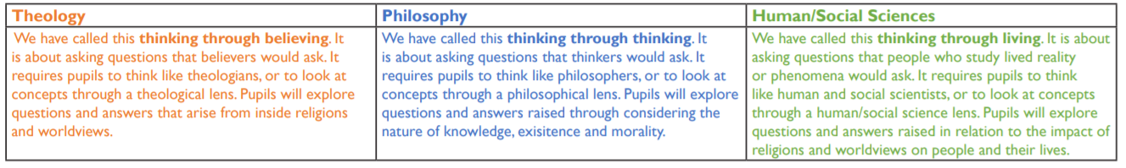
- To gain and deploy skills rooted in theology, philosophy and the human/social sciences engaging critically with religious and non-religious worldviews.

Objectives
- Children will learn about religions and religion – to ensure that religious education provides breadth and balance in both content and approaches to learning so that they become religiously literate.
- We provide opportunities for children of all abilities to develop their skills and knowledge in each unit and ensure the planned progress is built into the syllabus offers the children an increasing challenge as they move through the school which is shown through KS2 building upon what has already been taught in KS1 and EYFS. In addition, certain skills and attitudes are encouraged e.g. learning to respect the skills of others, asking questions and listening to others, personal reflection on life and its values.
- The teaching and learning strategies within RE lessons will vary through reading and writing opportunities linked to the English curriculum as well as having the opportunity to be creative in its broadest sense, such as through drama, art and computing.
- This year, teachers are being encouraged to ensure that their children have opportunities to encounter religions, faith and commitment through visits and visitors.
The RE Curriculum
At Nelson Academy the religious education curriculum forms an important part of our school’s spiritual, moral, social and cultural teaching. Our school RE curriculum follows the Norfolk Agreed Syllabus for Religious Education 2019. In accordance with the syllabus, the RE curriculum must:
- Promote the spiritual, moral, cultural, mental and physical development of pupils at school and of society.
- Prepare pupils at the school for opportunities, responsibilities and experiences of later life.
A parent of a pupil may request that their child be wholly or partly excused from receiving RE given accordance with the Agreed Syllabus.

Teaching and Learning style
At Nelson Academy we develop our RE learning from the ‘Discovery RE Scheme’ which provides an Enquiry-based learning approach which follows with the ‘Norfolk Agreed Syllabus 2012’. This enquiry-based approach is set within a climate of effective learning in RE where:
- An appropriate level of challenge is provided for all pupils.
- All pupils know they can achieve and there is an expectation of success.
- The learning is set in real and authentic context, with a clear purpose, meaning and relevance.
- A safe environment is created where all pupils are valued, so that they can confidently agree to disagree and express themselves freely.
- Pupils have a sense of ownership over what is being learned and how they are learning it.
- There is a clear learning journey and identifiable outcomes.
As the Agree Norfolk Syllabus states, the enquiry-based approach is seen as the best practice for teaching RE. The Discovery RE scheme provides an easy to follow enquiry process, that allows us to adapt to fit in with our topics.
The Discovery RE enquiry-based approach is broken down into the following lessons:
- Engagement – The human experience underpinning the key question is explored here with the children’s own experience, whether that includes religion or not. If they can relate to human experience they will be better able to understand the world of religion into which the enquiry takes place. This usually last for 1 lesson.
- Investigation – The teacher guides the children through the enquiry, learning about the key question from the previous lessons, developing subject knowledge which will assist their thinking about the key question. This usually lasts for 3 lessons.
- Evaluation – This lesson draws together children’s learning and their conclusions about the key of that enquiry. This is an assessment task which the teacher can then use to access what they children have learnt from the topic. This usually lasts for 1 lesson.
- Expression – Children are taken back to the Engagement lesson, their own experience, to reflect on how this enquiry might have influenced their own starting points and beliefs. This usually lasts for 1 lesson and classes are encouraged to create a display from what they have learnt.

Time spent on RE in accordance to the ‘Agreed Norfolk Syllabus 2012’:
- See Early Years Framework
- Key Stage 1 should be taught RE 36 hours per year.
- Key Stage 2 should be taught RE 45 hours per year.

Assessment:
Assessing RE is an integral part of teaching and learning and central to good practice. It should be process orientated reviewing the way that techniques and skills are applied purposefully by pupils to demonstrate their knowledge and understanding and skills that they have developed during a particular unit. Teachers will use assessments to form a judgement as to whether each child has learned all of the content included in ‘Discovery RE’ scheme. Teachers have the opportunity to use the Level descriptors that are provided by the scheme at the end of each enquiry. The levels are exemplified and tracking and record sheet are included, as are pupil self-assessment sheets. These ‘I can’ level descriptors may well lend themselves to meaningful and less onerous report writing, with evidence in children’s books from every Evaluation lesson. This will demonstrate achievement of particular objectives.

Resources
One of the targets for RE this year is to provide children with meaningful resources that will support their learning throughout the enquiry. Current resources will be reviewed and organised while the school look into ways of providing more resources to fit the needs of the topics that are being taught.

