Nursery
*Taken from master the curriculum
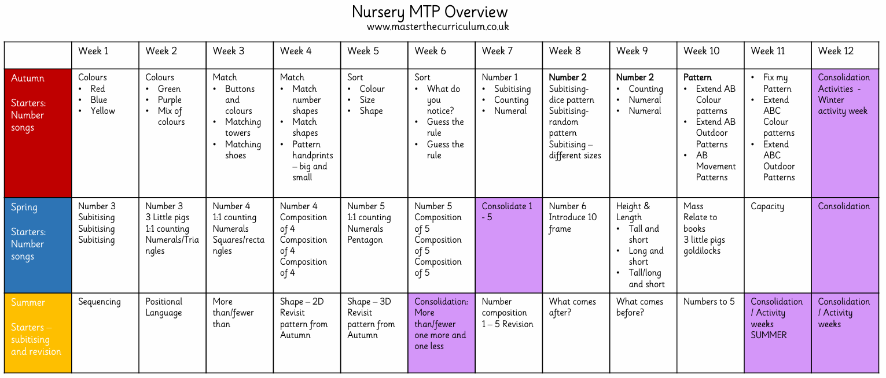

Using the White Rose mathematics scheme and overview (for small steps and progression)
Reception
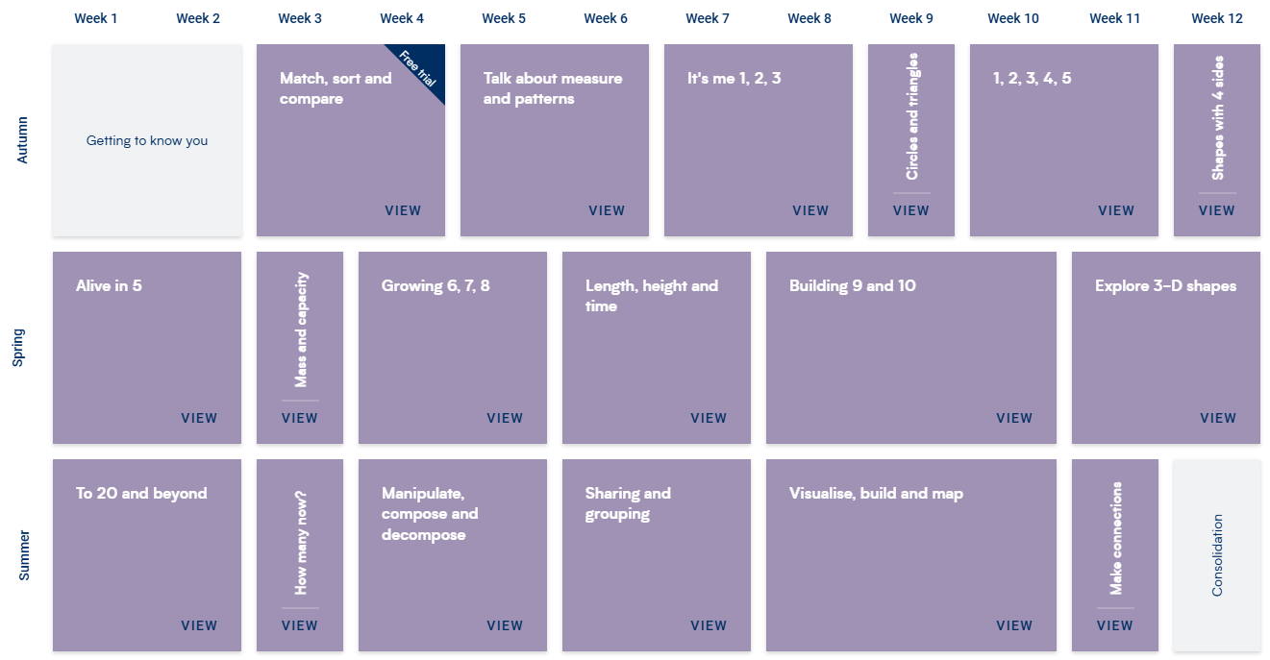

Year 1
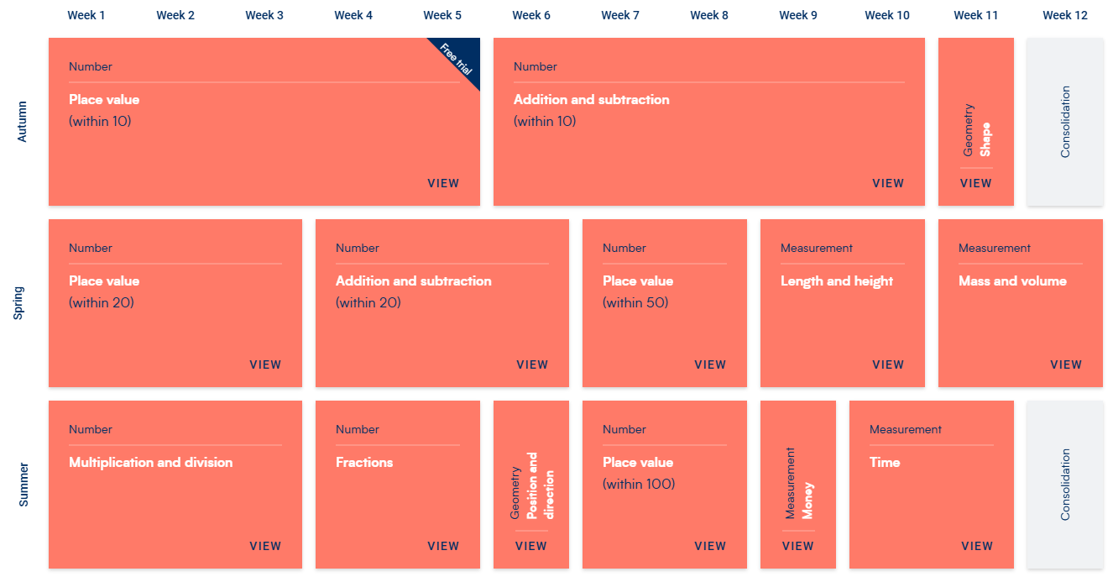

Year 1/2
 | Week 1 | Week 2 | Week 3 | Week 4 | Week 5 | Week 6 | Week 7 | Week 8 | Week 9 | Week 10 | Week 11 | Week 12
Autumn | Number  Place Value  (within 20) |  |  | Number  Addition and Subtraction  (within 20) |  |  | Number  Place Value  (within 100) |  |  |  | Number  Addition and Subtraction  (within 100)
Spring | Number  Multiplication and Division |  |  |  |  | Measurement  Money |  | Geometry  Shape |  | Measurement  Length and Height |  | Statistics
Summer | Number  Fractions |  |  |  | Measurement  Time |  |  | Measurement  Mass, Capacity and temperature |  |  | Geometry  Position and Direction

Year 2
 | Week 1 | Week 2 | Week 3 | Week 4 | Week 5 | Week 6 | Week 7 | Week 8 | Week 9 | Week 10 | Week 11 | Week 12
Autumn | Number  Place value  (to 100) |  |  |  |  | Number  Addition and Subtraction |  |  |  |  |  | Consolidation
Spring | Number  Multiplication and Division |  |  |  |  | Measurement  Money |  | Geometry  Shape |  | Measurement  Length and Height |  | Statistics
Summer | Number  Fractions |  |  |  | Measurement  Time |  |  | Measurement  Mass, Capacity and temperature |  |  | Geometry  Position and Direction

Year 3
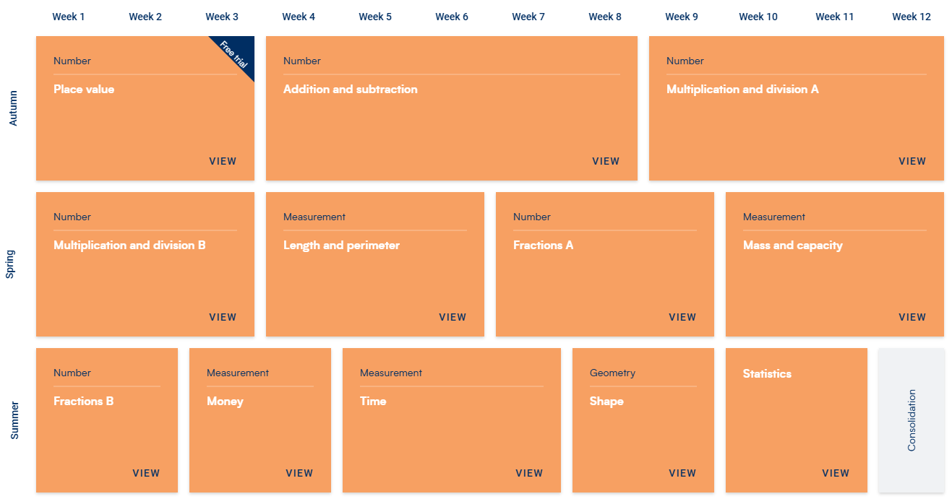

Year 4
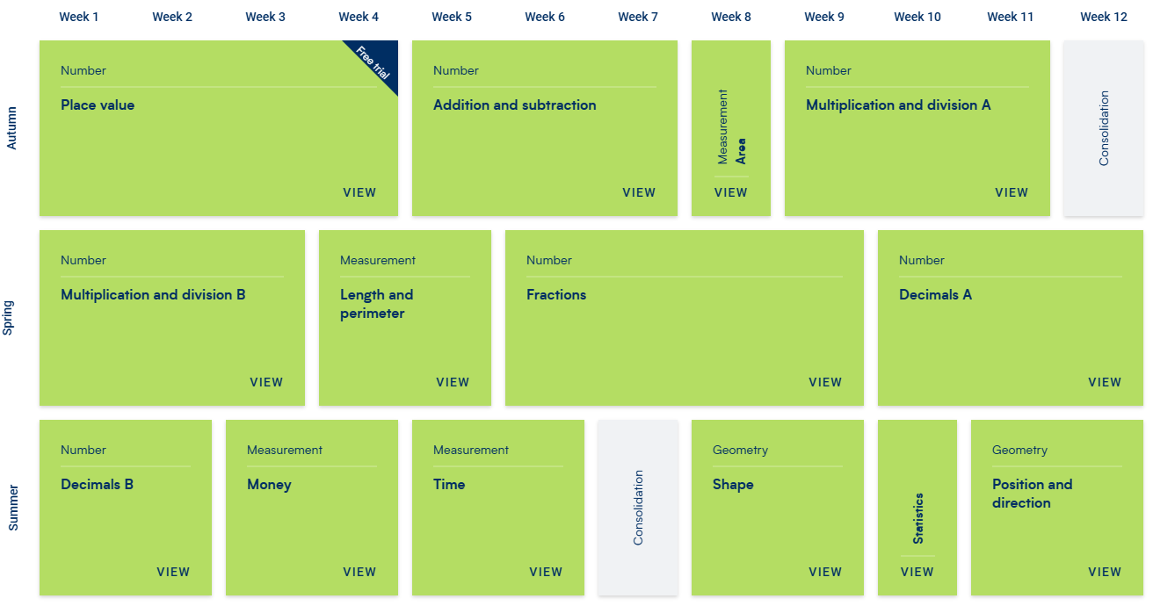

Year 5
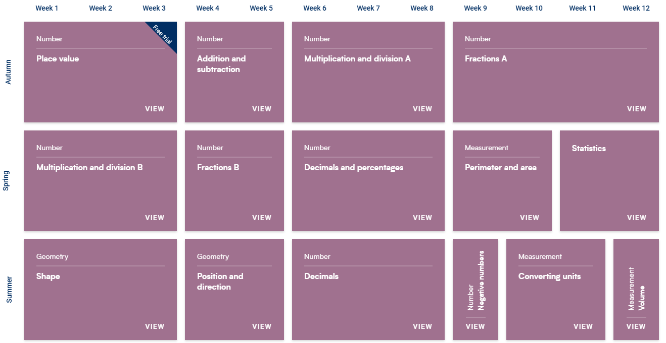

Year 6
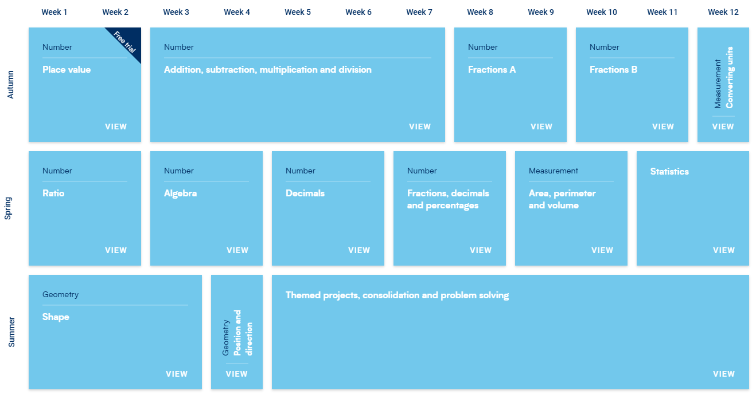

Curriculum Aims by the end of Key Stage – taken from the national curriculum programme of study
By the end of Key Stage 1, pupils will:
Year 1 | Year 2
Number – number and place value  - count to and across 100, forwards and backwards, beginning with 0 or 1, or from any given number  - count, read and write numbers to 100 in numerals; count in multiples of twos, fives and tens  - given a number, identify one more and one less  - identify and represent numbers using objects and pictorial representations including the number line, and use the language of: equal to, more than, less than (fewer), most, least  - read and write numbers from 1 to 20 in numerals and words  Number – addition and subtraction  - read, write and interpret mathematical statements involving addition (+), subtraction (–) and equals (=) signs  - represent and use number bonds and related subtraction facts within 20  - add and subtract one-digit and two-digit numbers to 20, including zero  - solve one-step problems that involve addition and subtraction, using concrete objects and pictorial representations, and missing number problems such as 7 = – 9.  Number – multiplication and division  - solve one-step problems involving multiplication and division, by calculating the answer using concrete objects, pictorial representations and arrays with the support of the teacher.  Number – fractions  - recognise, find and name a half as one of two equal parts of an object, shape or quantity  - recognise, find and name a quarter as one of four equal parts of an object, shape or quantity.  Measurement  - compare, describe and solve practical problems for:  - lengths and heights [for example, long/short, longer/shorter, tall/short, double/half]  - mass/weight [for example, heavy/light, heavier than, lighter than]  - capacity and volume [for example, full/empty, more than, less than, half, half full, quarter]  - time [for example, quicker, slower, earlier, later]  - measure and begin to record the following:  - lengths and heights  - mass/weight  - capacity and volume  - time (hours, minutes, seconds)  - recognise and know the value of different denominations of coins and notes  - sequence events in chronological order using language [for example, before and after, next, first, today, yesterday, tomorrow, morning, afternoon and evening]  - recognise and use language relating to dates, including days of the week, weeks, months and years  - tell the time to the hour and half past the hour and draw the hands on a clock face to show these times.  Geometry – properties of shapes  - recognise and name common 2-D and 3-D shapes, including:  - 2-D shapes [for example, rectangles (including squares), circles and triangles]  - 3-D shapes [for example, cuboids (including cubes), pyramids and spheres].  Geometry – position and direction  - describe position, direction and movement, including whole, half, quarter and threequarter turns. | Number – number and place value  - count in steps of 2, 3, and 5 from 0, and in tens from any number, forward and backward  - recognise the place value of each digit in a two-digit number (tens, ones)  - identify, represent and estimate numbers using different representations, including the number line  - compare and order numbers from 0 up to 100; use and = signs  - read and write numbers to at least 100 in numerals and in words  - use place value and number facts to solve problems  Number – addition and subtraction  - solve problems with addition and subtraction:  - using concrete objects and pictorial representations, including those involving numbers, quantities and measures  - applying their increasing knowledge of mental and written methods  - recall and use addition and subtraction facts to 20 fluently, and derive and use related facts up to 100  - add and subtract numbers using concrete objects, pictorial representations, and mentally, including:  - a two-digit number and ones  - a two-digit number and tens  - two two-digit numbers  - adding three one-digit numbers  - show that addition of two numbers can be done in any order (commutative) and subtraction of one number from another cannot  - recognise and use the inverse relationship between addition and subtraction and use this to check calculations and solve missing number problems.  Number – multiplication and division  - recall and use multiplication and division facts for the 2, 5 and 10 multiplication tables, including recognising odd and even numbers  - calculate mathematical statements for multiplication and division within the multiplication tables and write them using the multiplication (×), division (÷) and equals (=) signs  - show that multiplication of two numbers can be done in any order (commutative) and division of one number by another cannot  - solve problems involving multiplication and division, using materials, arrays, repeated addition, mental methods, and multiplication and division facts, including problems in contexts.  Number – fractions  - recognise, find, name and write fractions 3 1 , 4 1 , 4 2 and 4 3 of a length, shape, set of objects or quantity  - write simple fractions for example, 2 1 of 6 = 3 and recognise the equivalence of 4 2 and 2 1.  Measurement  - choose and use appropriate standard units to estimate and measure length/height in any direction (m/cm); mass (kg/g); temperature (°C); capacity (litres/ml) to the nearest appropriate unit, using rulers, scales, thermometers and measuring vessels  - compare and order lengths, mass, volume/capacity and record the results using >, < and =  - recognise and use symbols for pounds (£) and pence (p); combine amounts to make a particular value  - find different combinations of coins that equal the same amounts of money  - solve simple problems in a practical context involving addition and subtraction of money of the same unit, including giving change  - compare and sequence intervals of time  - tell and write the time to five minutes, including quarter past/to the hour and draw the hands on a clock face to show these times  - know the number of minutes in an hour and the number of hours in a day.  Geometry – properties of shapes  - identify and describe the properties of 2-D shapes, including the number of sides and line symmetry in a vertical line  - identify and describe the properties of 3-D shapes, including the number of edges, vertices and faces  - identify 2-D shapes on the surface of 3-D shapes, [for example, a circle on a cylinder and a triangle on a pyramid]  - compare and sort common 2-D and 3-D shapes and everyday objects.  Geometry – position and direction  - order and arrange combinations of mathematical objects in patterns and sequences  - use mathematical vocabulary to describe position, direction and movement, including movement in a straight line and distinguishing between rotation as a turn and in terms of right angles for quarter, half and three-quarter turns (clockwise and anticlockwise).  Statistics  - interpret and construct simple pictograms, tally charts, block diagrams and simple tables  - ask and answer simple questions by counting the number of objects in each category and sorting the categories by quantity  - ask and answer questions about totalling and comparing categorical data.

By the end of Lower Key Stage 2, pupils will:
Year 3 | Year 4
Number – number and place value  - count from 0 in multiples of 4, 8, 50 and 100; find 10 or 100 more or less than a given number  - recognise the place value of each digit in a three-digit number (hundreds, tens, ones)  - compare and order numbers up to 1000  - identify, represent and estimate numbers using different representations  - read and write numbers up to 1000 in numerals and in words  - solve number problems and practical problems involving these ideas.  Number – addition and subtraction  - add and subtract numbers mentally, including:  - a three-digit number and ones  - a three-digit number and tens  - a three-digit number and hundreds  - add and subtract numbers with up to three digits, using formal written methods of columnar addition and subtraction  - estimate the answer to a calculation and use inverse operations to check answers  - solve problems, including missing number problems, using number facts, place value, and more complex addition and subtraction.  Number – multiplication and division  - recall and use multiplication and division facts for the 3, 4 and 8 multiplication tables  - write and calculate mathematical statements for multiplication and division using the multiplication tables that they know, including for two-digit numbers times one-digit numbers, using mental and progressing to formal written methods  - solve problems, including missing number problems, involving multiplication and division, including positive integer scaling problems and correspondence problems in which n objects are connected to m objects.  Number – fractions  - count up and down in tenths; recognise that tenths arise from dividing an object into 10 equal parts and in dividing one-digit numbers or quantities by 10  - recognise, find and write fractions of a discrete set of objects: unit fractions and nonunit fractions with small denominators  - recognise and use fractions as numbers: unit fractions and non-unit fractions with small denominators  - recognise and show, using diagrams, equivalent fractions with small denominators  - add and subtract fractions with the same denominator within one whole [for example, 7 5 + 7 1 = 7 6 ]  - compare and order unit fractions, and fractions with the same denominators  - solve problems that involve all of the above.  Measurement  - measure, compare, add and subtract: lengths (m/cm/mm); mass (kg/g); volume/capacity (l/ml)  - measure the perimeter of simple 2-D shapes  - add and subtract amounts of money to give change, using both £ and p in practical contexts  - tell and write the time from an analogue clock, including using Roman numerals from I to XII, and 12-hour and 24-hour clocks  - estimate and read time with increasing accuracy to the nearest minute; record and compare time in terms of seconds, minutes and hours; use vocabulary such as o’clock, a.m./p.m., morning, afternoon, noon and midnight  - know the number of seconds in a minute and the number of days in each month, year and leap year  - compare durations of events [for example to calculate the time taken by particular events or tasks].  Geometry – properties of shapes  - draw 2-D shapes and make 3-D shapes using modelling materials; recognise 3-D shapes in different orientations and describe them  - recognise angles as a property of shape or a description of a turn  - identify right angles, recognise that two right angles make a half-turn, three make three quarters of a turn and four a complete turn; identify whether angles are greater than or less than a right angle  - identify horizontal and vertical lines and pairs of perpendicular and parallel lines.  Statistics  - interpret and present data using bar charts, pictograms and tables  - solve one-step and two-step questions [for example, ‘How many more?’ and ‘How many fewer?’] using information presented in scaled bar charts and pictograms and tables. | Number – number and place value  - count in multiples of 6, 7, 9, 25 and 1000  - find 1000 more or less than a given number  - count backwards through zero to include negative numbers  - recognise the place value of each digit in a four-digit number (thousands, hundreds, tens, and ones)  - order and compare numbers beyond 1000  - identify, represent and estimate numbers using different representations  - round any number to the nearest 10, 100 or 1000  - solve number and practical problems that involve all of the above and with increasingly large positive numbers  - read Roman numerals to 100 (I to C) and know that over time, the numeral system changed to include the concept of zero and place value.  Number – addition and subtraction  - add and subtract numbers with up to 4 digits using the formal written methods of columnar addition and subtraction where appropriate  - estimate and use inverse operations to check answers to a calculation  - solve addition and subtraction two-step problems in contexts, deciding which operations and methods to use and why.  Number – multiplication and division  - recall multiplication and division facts for multiplication tables up to 12 × 12  - use place value, known and derived facts to multiply and divide mentally, including: multiplying by 0 and 1; dividing by 1; multiplying together three numbers  - recognise and use factor pairs and commutativity in mental calculations  - multiply two-digit and three-digit numbers by a one-digit number using formal written layout  - solve problems involving multiplying and adding, including using the distributive law to multiply two digit numbers by one digit, integer scaling problems and harder correspondence problems such as n objects are connected to m objects.  Number – fractions  - recognise and show, using diagrams, families of common equivalent fractions  - count up and down in hundredths; recognise that hundredths arise when dividing an object by one hundred and dividing tenths by ten.  - solve problems involving increasingly harder fractions to calculate quantities, and fractions to divide quantities, including non-unit fractions where the answer is a whole number  - add and subtract fractions with the same denominator  - recognise and write decimal equivalents of any number of tenths or hundredths  - recognise and write decimal equivalents to 4 1 , 2 1 , 4 3  - find the effect of dividing a one- or two-digit number by 10 and 100, identifying the value of the digits in the answer as ones, tenths and hundredths  - round decimals with one decimal place to the nearest whole number  - compare numbers with the same number of decimal places up to two decimal places  - solve simple measure and money problems involving fractions and decimals to two decimal places.  Measurement  - Convert between different units of measure [for example, kilometre to metre; hour to minute]  - measure and calculate the perimeter of a rectilinear figure (including squares) in centimetres and metres  - find the area of rectilinear shapes by counting squares  - estimate, compare and calculate different measures, including money in pounds and pence  - read, write and convert time between analogue and digital 12- and 24-hour clocks  - solve problems involving converting from hours to minutes; minutes to seconds; years to months; weeks to days.  Geometry – properties of shapes  - compare and classify geometric shapes, including quadrilaterals and triangles, based on their properties and sizes  - identify acute and obtuse angles and compare and order angles up to two right angles by size  - identify lines of symmetry in 2-D shapes presented in different orientations  - complete a simple symmetric figure with respect to a specific line of symmetry.  Geometry – position and direction  - describe positions on a 2-D grid as coordinates in the first quadrant  - describe movements between positions as translations of a given unit to the left/right and up/down  - plot specified points and draw sides to complete a given polygon.  Statistics  - interpret and present discrete and continuous data using appropriate graphical methods, including bar charts and time graphs.  - solve comparison, sum and difference problems using information presented in bar charts, pictograms, tables and other graphs.

By the end of Upper Key Stage 2, pupils will:
Year 5 | Year 6
Number – number and place value  - read, write, order and compare numbers to at least 1 000 000 and determine the value of each digit  - count forwards or backwards in steps of powers of 10 for any given number up to 1 000 000  - interpret negative numbers in context, count forwards and backwards with positive and negative whole numbers, including through zero  - round any number up to 1 000 000 to the nearest 10, 100, 1000, 10 000 and 100 000  - solve number problems and practical problems that involve all of the above  - read Roman numerals to 1000 (M) and recognise years written in Roman numerals.  Number – addition and subtraction  - add and subtract whole numbers with more than 4 digits, including using formal written methods (columnar addition and subtraction)  - add and subtract numbers mentally with increasingly large numbers  - use rounding to check answers to calculations and determine, in the context of a problem, levels of accuracy  - solve addition and subtraction multi-step problems in contexts, deciding which operations and methods to use and why.  Number – multiplication and division  - identify multiples and factors, including finding all factor pairs of a number, and common factors of two numbers  - know and use the vocabulary of prime numbers, prime factors and composite (nonprime) numbers  - establish whether a number up to 100 is prime and recall prime numbers up to 19  - multiply numbers up to 4 digits by a one- or two-digit number using a formal written method, including long multiplication for two-digit numbers  - multiply and divide numbers mentally drawing upon known facts  - divide numbers up to 4 digits by a one-digit number using the formal written method of short division and interpret remainders appropriately for the context  - multiply and divide whole numbers and those involving decimals by 10, 100 and 1000  - recognise and use square numbers and cube numbers, and the notation for squared ( 2 ) and cubed (3 )  - solve problems involving multiplication and division including using their knowledge of factors and multiples, squares and cubes  - solve problems involving addition, subtraction, multiplication and division and a combination of these, including understanding the meaning of the equals sign  - solve problems involving multiplication and division, including scaling by simple fractions and problems involving simple rates.  Number – fractions  - compare and order fractions whose denominators are all multiples of the same number  - identify, name and write equivalent fractions of a given fraction, represented visually, including tenths and hundredths  - recognise mixed numbers and improper fractions and convert from one form to the other and write mathematical statements > 1 as a mixed number [for example, 5 2 + 5 4 = 5 6 = 1 5 1 ]  - add and subtract fractions with the same denominator and denominators that are multiples of the same number  - multiply proper fractions and mixed numbers by whole numbers, supported by materials and diagrams  - read and write decimal numbers as fractions [for example, 0.71 = 100 71 ]  - recognise and use thousandths and relate them to tenths, hundredths and decimal equivalents  - round decimals with two decimal places to the nearest whole number and to one decimal place  - read, write, order and compare numbers with up to three decimal places  - solve problems involving number up to three decimal places  - recognise the per cent symbol (%) and understand that per cent relates to ‘number of parts per hundred’, and write percentages as a fraction with denominator 100, and as a decimal  - solve problems which require knowing percentage and decimal equivalents of 2 1 , 4 1 , 5 1 , 5 2 , 5 4 and those fractions with a denominator of a multiple of 10 or 25.  Measurement  - convert between different units of metric measure (for example, kilometre and metre; centimetre and metre; centimetre and millimetre; gram and kilogram; litre and millilitre)  - understand and use approximate equivalences between metric units and common imperial units such as inches, pounds and pints  - measure and calculate the perimeter of composite rectilinear shapes in centimetres and metres  - calculate and compare the area of rectangles (including squares), and including using standard units, square centimetres (cm2 ) and square metres (m2 ) and estimate the area of irregular shapes  - estimate volume [for example, using 1 cm3 blocks to build cuboids (including cubes)] and capacity [for example, using water]  - solve problems involving converting between units of time  - use all four operations to solve problems involving measure [for example, length, mass, volume, money] using decimal notation, including scaling.  Geometry – properties of shapes  - identify 3-D shapes, including cubes and other cuboids, from 2-D representations  - know angles are measured in degrees: estimate and compare acute, obtuse and reflex angles  - draw given angles, and measure them in degrees (o )  - identify:  - angles at a point and one whole turn (total 360o )  - angles at a point on a straight line and 2 1 a turn (total 180o )  - other multiples of 90o  - use the properties of rectangles to deduce related facts and find missing lengths and angles  - distinguish between regular and irregular polygons based on reasoning about equal sides and angles.  Geometry – position and direction  - identify, describe and represent the position of a shape following a reflection or translation, using the appropriate language, and know that the shape has not changed.  Statistics  - solve comparison, sum and difference problems using information presented in a line graph  - complete, read and interpret information in tables, including timetables. | Number – number and place value  - read, write, order and compare numbers up to 10 000 000 and determine the value of each digit  - round any whole number to a required degree of accuracy  - use negative numbers in context, and calculate intervals across zero  - solve number and practical problems that involve all of the above.  Number – addition, subtraction, multiplication and division  - multiply multi-digit numbers up to 4 digits by a two-digit whole number using the formal written method of long multiplication  - divide numbers up to 4 digits by a two-digit whole number using the formal written method of long division, and interpret remainders as whole number remainders, fractions, or by rounding, as appropriate for the context  - divide numbers up to 4 digits by a two-digit number using the formal written method of short division where appropriate, interpreting remainders according to the context  - perform mental calculations, including with mixed operations and large numbers  - identify common factors, common multiples and prime numbers  - use their knowledge of the order of operations to carry out calculations involving the four operations  - solve addition and subtraction multi-step problems in contexts, deciding which operations and methods to use and why  - solve problems involving addition, subtraction, multiplication and division  - use estimation to check answers to calculations and determine, in the context of a problem, an appropriate degree of accuracy.  Number – fractions (including decimals and percentages)  - use common factors to simplify fractions; use common multiples to express fractions in the same denomination  - compare and order fractions, including fractions > 1  - add and subtract fractions with different denominators and mixed numbers, using the concept of equivalent fractions  - multiply simple pairs of proper fractions, writing the answer in its simplest form [for example, 4 1 × 2 1 = 8 1 ]  - divide proper fractions by whole numbers [for example, 3 1 ÷ 2 = 6 1 ]  - associate a fraction with division and calculate decimal fraction equivalents [for example, 0.375] for a simple fraction [for example, 8 3 ]  - identify the value of each digit in numbers given to three decimal places and multiply and divide numbers by 10, 100 and 1000 giving answers up to three decimal places  - multiply one-digit numbers with up to two decimal places by whole numbers  - use written division methods in cases where the answer has up to two decimal places  - solve problems which require answers to be rounded to specified degrees of accuracy  - recall and use equivalences between simple fractions, decimals and percentages, including in different contexts.  Ratio and proportion  - solve problems involving the relative sizes of two quantities where missing values can be found by using integer multiplication and division facts  - solve problems involving the calculation of percentages [for example, of measures, and such as 15% of 360] and the use of percentages for comparison  - solve problems involving similar shapes where the scale factor is known or can be found  - solve problems involving unequal sharing and grouping using knowledge of fractions and multiples.  Algebra  - use simple formulae  - generate and describe linear number sequences ♣ express missing number problems algebraically  - find pairs of numbers that satisfy an equation with two unknowns  - enumerate possibilities of combinations of two variables.  Measurement  - solve problems involving the calculation and conversion of units of measure, using decimal notation up to three decimal places where appropriate  - use, read, write and convert between standard units, converting measurements of length, mass, volume and time from a smaller unit of measure to a larger unit, and vice versa, using decimal notation to up to three decimal places  - convert between miles and kilometres  - recognise that shapes with the same areas can have different perimeters and vice versa  - recognise when it is possible to use formulae for area and volume of shapes  - calculate the area of parallelograms and triangles  - calculate, estimate and compare volume of cubes and cuboids using standard units, including cubic centimetres (cm3 ) and cubic metres (m3 ), and extending to other units [for example, mm3 and km3 ].  Geometry – properties of shapes  - draw 2-D shapes using given dimensions and angles  - recognise, describe and build simple 3-D shapes, including making nets  - compare and classify geometric shapes based on their properties and sizes and find unknown angles in any triangles, quadrilaterals, and regular polygons  - illustrate and name parts of circles, including radius, diameter and circumference and know that the diameter is twice the radius  - recognise angles where they meet at a point, are on a straight line, or are vertically opposite, and find missing angles.  Geometry – position and direction  - describe positions on the full coordinate grid (all four quadrants)  - draw and translate simple shapes on the coordinate plane, and reflect them in the axes.  Statistics  - interpret and construct pie charts and line graphs and use these to solve problems  - calculate and interpret the mean as an average

